HDLC Configuration in Cisco Packet Tracer
HDLC (High-Level Data Link Control) is a Data Link Layer protocol used for communication between routers over a point-to-point serial link. In Cisco Packet Tracer, you can configure HDLC between two routers and verify connectivity using the ping command.
1. Objective
To configure and verify HDLC encapsulation between two routers in Cisco Packet Tracer.
2. Network Topology
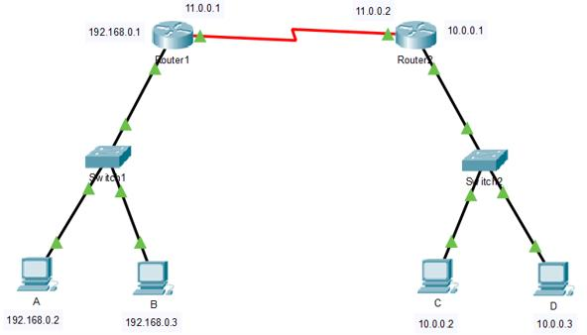
Create the following topology:
PC0 -------- R1 ================= R2 -------- PC1
S0/0/0 S0/0/0
Here, ==== represents a serial connection between the routers.
Devices required
- 2 Routers (e.g., Cisco 2911 with suitable serial modules, or another router model supporting serial interfaces)
- 2 PCs
- 2 Copper straight-through cables
- 1 Serial DCE/DTE cable
Important: If your router does not have serial interfaces, switch it off in the Physical tab, install a compatible serial module such as WIC-2T, and switch it back on.
3. IP Addressing Table
Device | Interface | IP Address | Subnet Mask
PC0 | FastEthernet0 | 192.168.1.2 | 255.255.255.0
R1 | GigabitEthernet0/0 | 192.168.1.1 | 255.255.255.0
R1 | Serial0/0/0 | 10.0.0.1 | 255.255.255.252
R2 | Serial0/0/0 | 10.0.0.2 | 255.255.255.252
R2 | GigabitEthernet0/0 | 192.168.2.1 | 255.255.255.0
PC1 | FastEthernet0 | 192.168.2.2 | 255.255.255.0
Default gateways:
- PC0: 192.168.1.1
- PC1: 192.168.2.1
4. Configure PC IP Addresses
For PC0:
- Click PC0.
- Open Desktop → IP Configuration.
- Enter:
  - IP Address: 192.168.1.2
  - Subnet Mask: 255.255.255.0
  - Default Gateway: 192.168.1.1
For PC1:
- Click PC1.
- Open Desktop → IP Configuration.
- Enter:
  - IP Address: 192.168.2.2
  - Subnet Mask: 255.255.255.0
  - Default Gateway: 192.168.2.1

5. Configure Router R1
Click R1, open the CLI, and enter:
enable
configure terminal
hostname R1

interface gigabitEthernet 0/0
ip address 192.168.1.1 255.255.255.0
no shutdown
exit

interface serial 0/0/0
ip address 10.0.0.1 255.255.255.252
encapsulation hdlc
no shutdown
exit

ip route 192.168.2.0 255.255.255.0 10.0.0.2

end
write memory
If R1 is the DCE side
Check the interface using:
show controllers serial 0/0/0
If it is the DCE side, configure a clock rate:
configure terminal
interface serial 0/0/0
clock rate 64000
end
The clock rate is configured on the DCE end of the serial connection only.

6. Configure Router R2
Click R2, open the CLI, and enter:
enable
configure terminal
hostname R2

interface gigabitEthernet 0/0
ip address 192.168.2.1 255.255.255.0
no shutdown
exit

interface serial 0/0/0
ip address 10.0.0.2 255.255.255.252
encapsulation hdlc
no shutdown
exit

ip route 192.168.1.0 255.255.255.0 10.0.0.1

end
write memory
Note: Both routers must use compatible serial encapsulation settings. Cisco HDLC is typically the default encapsulation on Cisco serial interfaces, but explicitly configuring encapsulation hdlc makes the practical clear.

7. Verify HDLC Configuration
Step 1: Check the interface status
On R1 and R2, run:
show ip interface brief
Expected status:
Interface IP-Address Status Protocol
Serial0/0/0 10.0.0.1 up up
The serial interface should show up/up on both routers.
Step 2: Verify encapsulation
On R1, execute:
show interfaces serial 0/0/0
Look for output similar to:
Serial0/0/0 is up, line protocol is up
Encapsulation HDLC
This confirms that HDLC encapsulation is configured.
Step 3: Test router-to-router connectivity
From R1:
ping 10.0.0.2
Successful responses confirm connectivity between the routers.
Step 4: Test end-to-end connectivity
On PC0, open Desktop → Command Prompt and run:
ping 192.168.2.2
If the configuration is correct, PC0 should be able to communicate with PC1 through both routers.
The first ping may time out while ARP entries are being established. If that happens, run the ping again.

8. Troubleshooting
Problem | Possible solution
Serial interface is down | Check the cable and execute no shutdown.
Interface remains down/down | Check the physical connection, module installation, and interface status.
Interface is up/down | Check encapsulation compatibility and DCE clock configuration.
Router-to-router ping fails | Verify serial IP addresses and subnet masks.
Router ping works, but PC-to-PC ping fails | Verify static routes, PC IP addresses, and default gateways.
encapsulation hdlc is rejected | Check whether the selected interface and router model support serial HDLC configuration.

9. Result
HDLC encapsulation was configured on the serial interfaces of two routers in Cisco Packet Tracer. The configuration was verified using the show interfaces serial 0/0/0 command, and connectivity was tested using ICMP ping.
Viva Questions
- What is HDLC?
- At which OSI layer does HDLC operate?
- What is the purpose of the encapsulation hdlc command?
- What is the difference between HDLC and PPP?
- Why is a clock rate required on the DCE side?
- Which command verifies the encapsulation configured on a serial interface?
- Why are static routes required in this topology?

